**PROJECT REPORT**

***INTRODUCTION:***

My name is Bidhan Bhusal.Iam currently studying bsc csit in second semester at Butwal Multiple Campus.I have recently joined Learn N share organization and am currently working on my phase -|| project.

***PROJECT OVERVIEW:***

My project for this phase was to copy the brochure .

***EXPERIENCE :***

I have been doing photoshop courses online for a long time. Previously, i have submitted a project for phase | . Now it's time for the second phase to present a brochure. I have been loving doing projects .

***TOOLS AND RESOURCES:***

I used Adobe Photoshop for this project .Copying a brochure was a little difficult for me in managing shape colours,etc. I used tools like pen tools, brush , color and entire tools which are in photoshop .

***PROJECT SCHEDULE***

I started doing the project on 28 september and due to some health problems , I completed it on 11 Oct.

***PROJECT ISSUES:***

So Basically there were some minor issues that occurred during these projects like stroke problems, shape , size, color,etc. It didn't keep me stuck for longer . I took help from my team and searched online for a solution.

***SCREENSHOTS:***

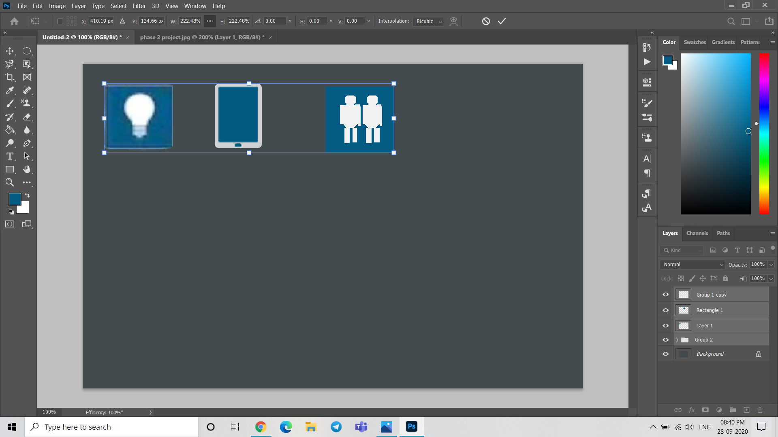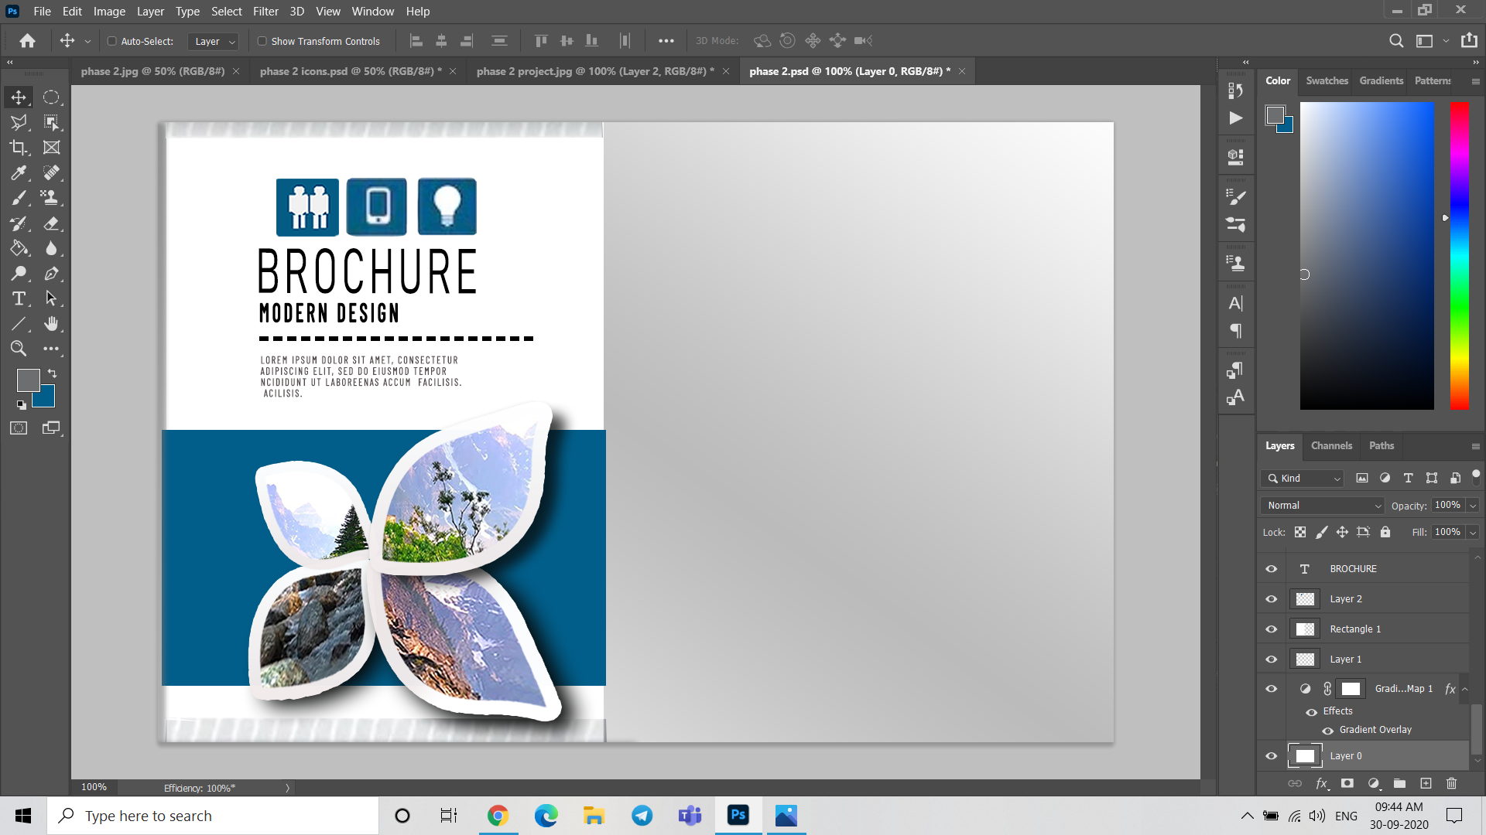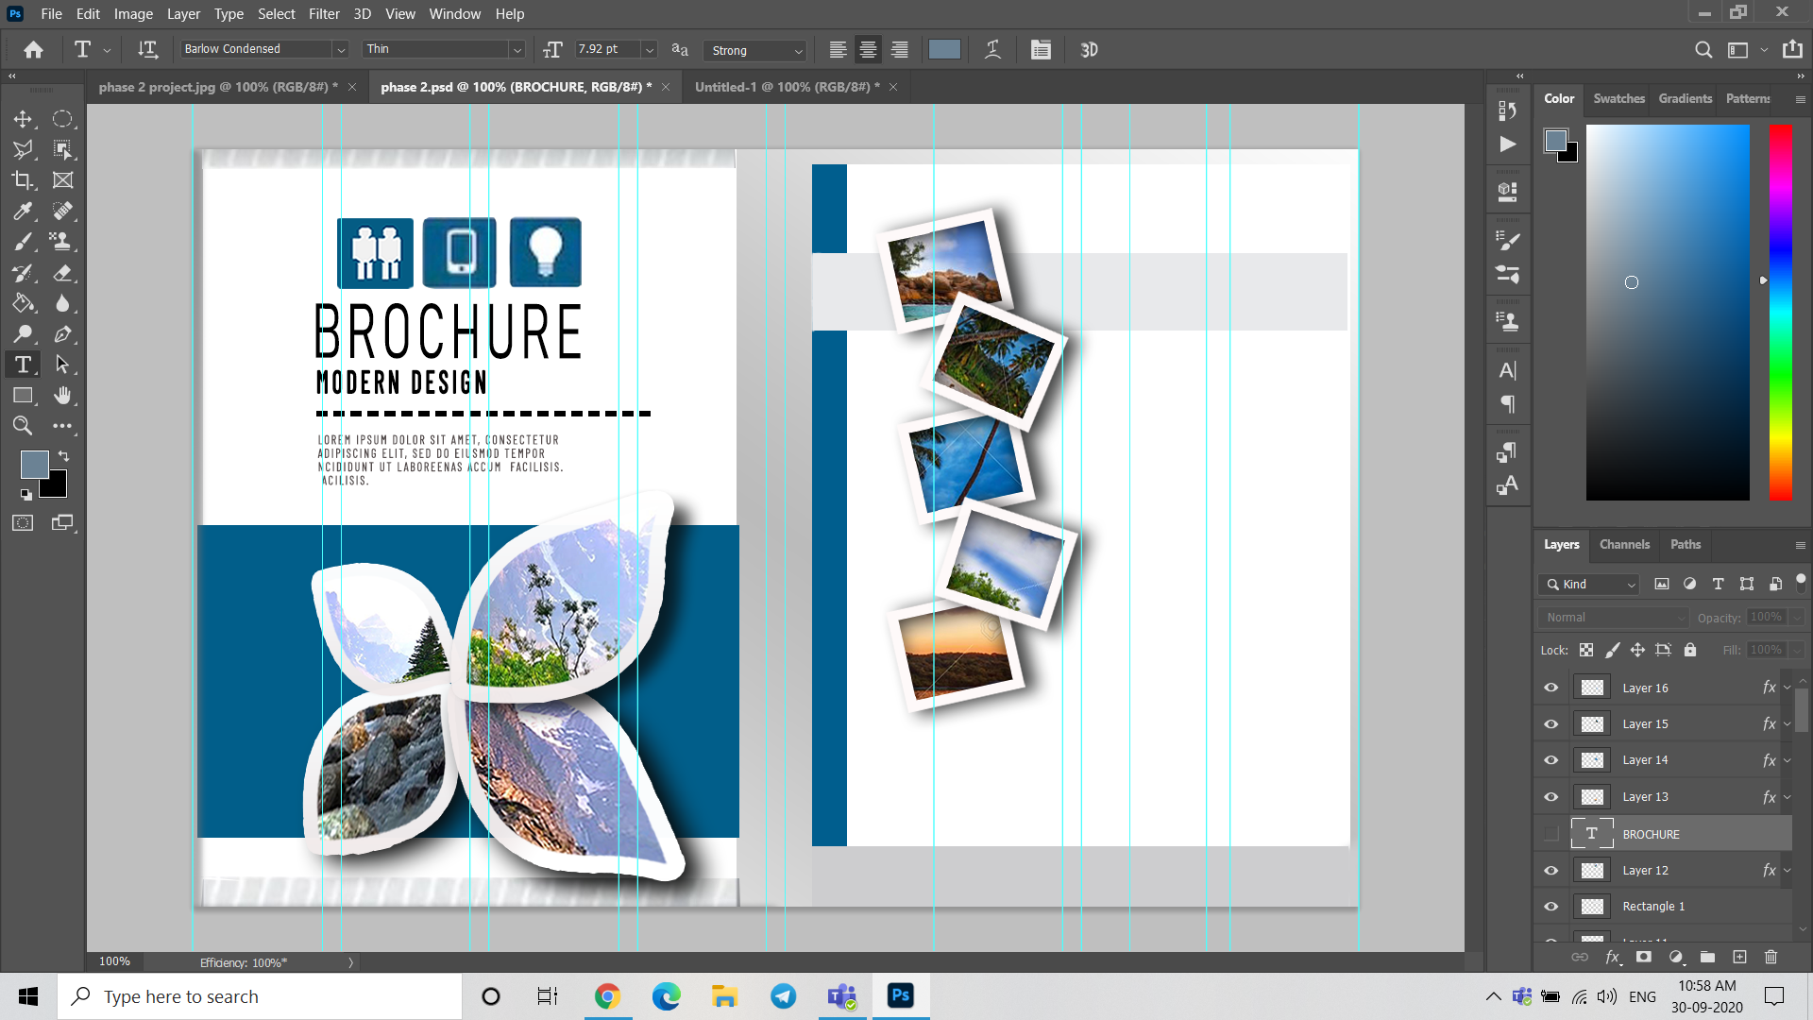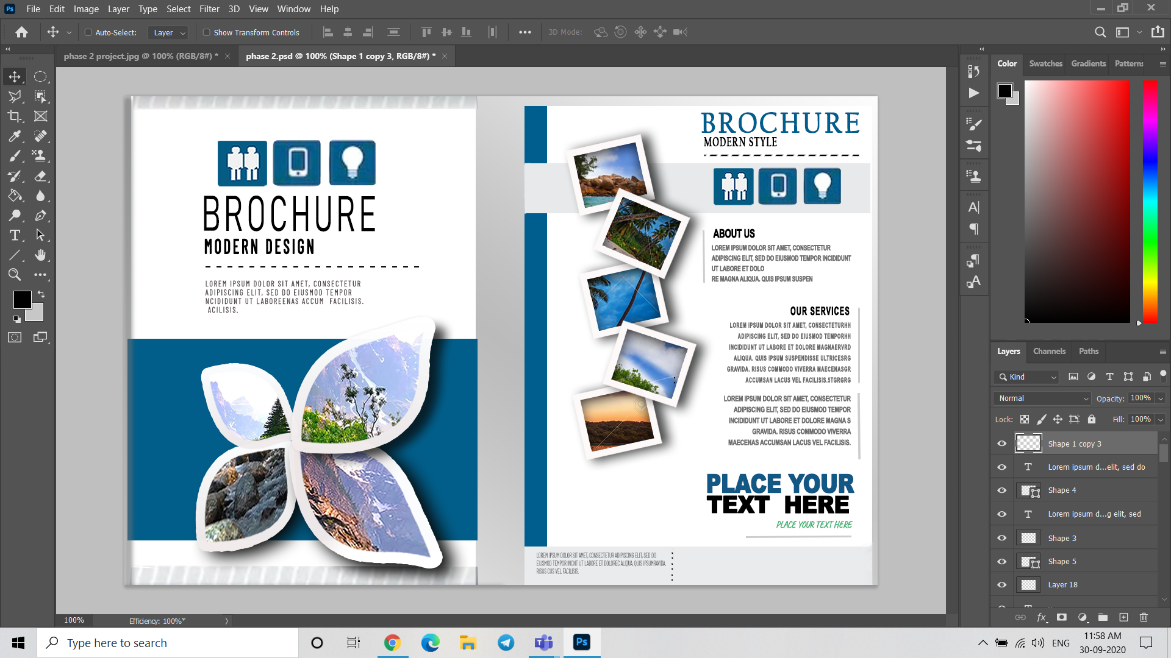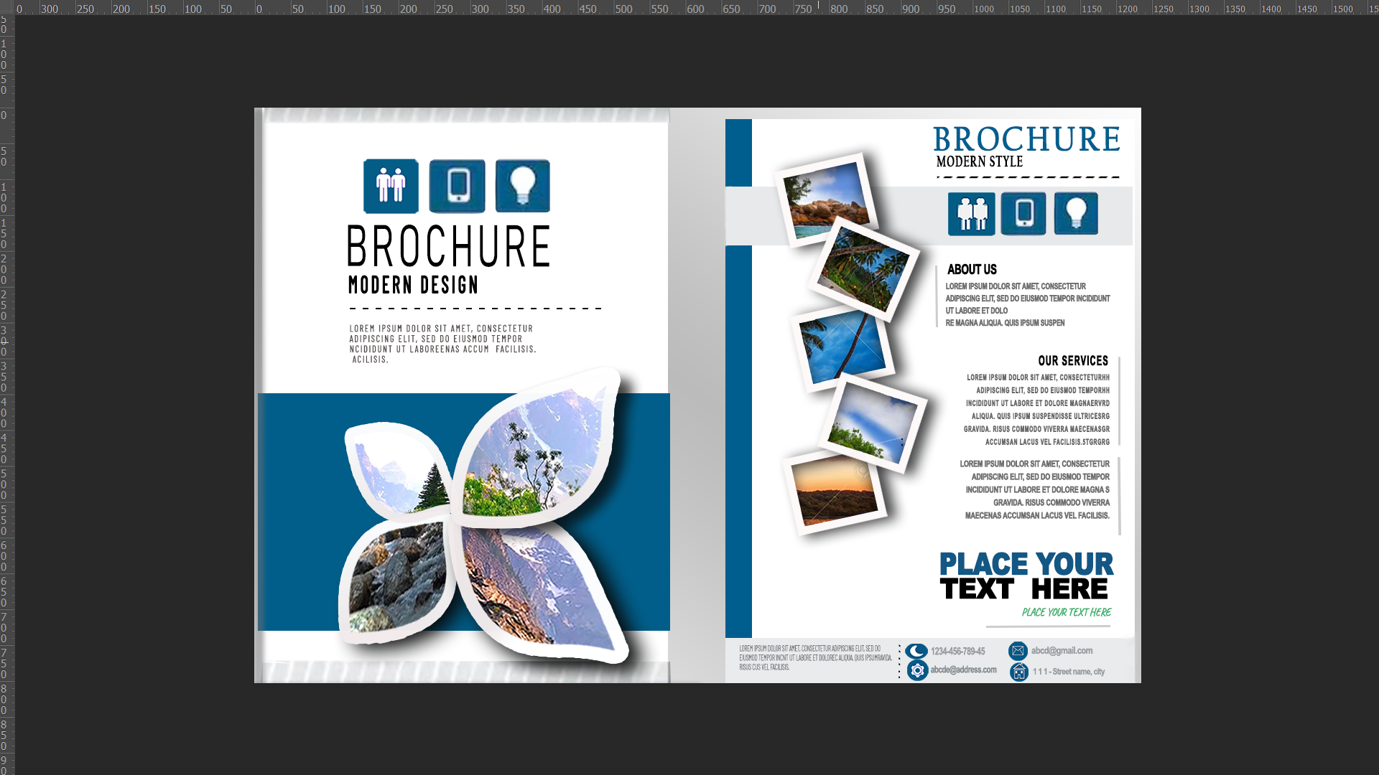

This is the logo for a **DESIGN HOUSE** which I had tried. 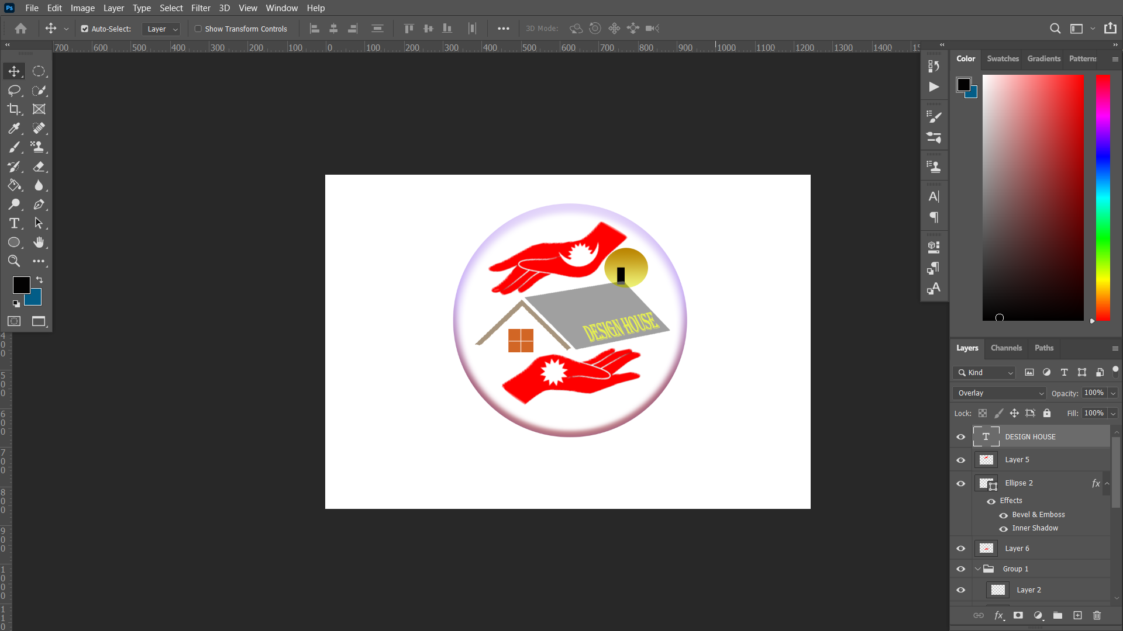 I have submitted everything regarding projects with this report.